
Introduction to Electrical Engineering
Lab Report
Name: Pranesh Chowdhury
ID: 202003112
Course ID: 112
Section: 2
Experiment No: 8
Experiment Name: Maximum Power Transfer Theorem

Objective:
The primary object of this experiment is to confirm the maximum power transfer theorem. For this, we need to check by estimation, that greatest force is created in a heap when the load opposition is equivalent to the inner obstruction of the source. At that point, we need to build a diagram, utilizing estimated estimations of voltage, current also, load opposition and determined capacity to confirm graphically.

List of Equipment:
- Wires
- Resistors
- PSIM Software
- DC Power Supply
- Ammeters

Circuit Diagram:

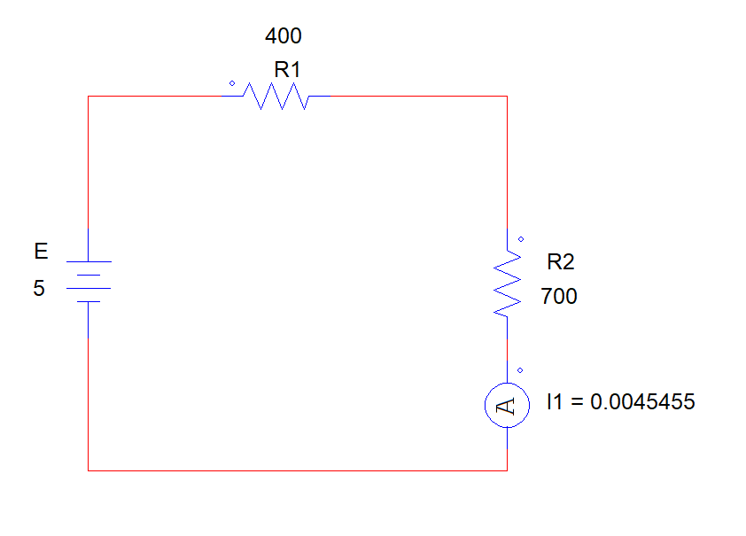

Data Table:

Observation | RL Ohms(measured) | I (measured) | Power Consumed by RL
1 | 100 | 0.01 | 0.01
2 | 200 | 0.0083333 | 0.013888778
3 | 300 | 0.0071429 | 0.015306306
4 | 350 | 0.0066667 | 0.015555711
5 | 380 | 0.0064103 | 0.01561494
6 | 390 | 0.0063291 | 0.015622428
7 | 400 | 0.00625 | 0.015625
8 | 410 | 0.0061728 | 0.015622419
9 | 420 | 0.0060976 | 0.015615905
10 | 450 | 0.0058824 | 0.015571183
11 | 500 | 0.0055556 | 0.015432346
12 | 600 | 0.005 | 0.015
13 | 700 | 0.0045455 | 0.014463099

Here,
P = I^2 * R
= (0.00454 A) ^ 2 * 700 Ohms
= 0.01446 W
Graph:

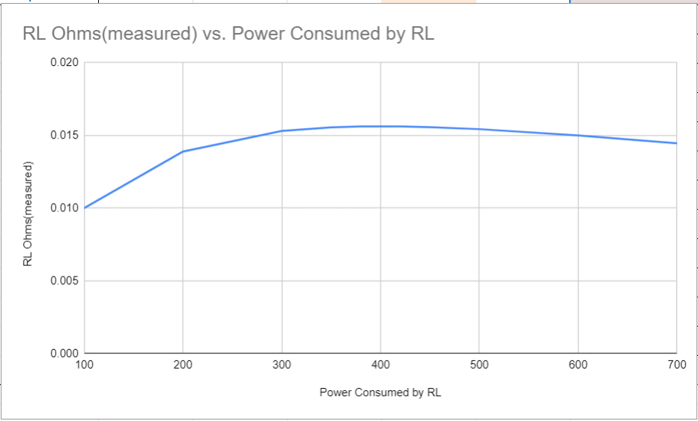

Discussion:
From the experiment we have come to think about the practical information on the maximum power transfer theorem. Furthermore, we should be cautious while plotting the right value in the table and likewise while connecting the wires and ammeter in the circuit.

